Vale Air Commodore (Retired) John Stewart “Stew” Back (AFC)

27 July 1937 – 1 January 2026

EDUCATED – KYEEMAGH INFANTS SCHOOL, ROCKDALE PRIMARY,

CANTERBURY BOYS’ HIGH - 1949-1953 MATRICULATED AGED 16

Entered No 7 Course RAAF College 18 Jan 1954, flight grading – May 1954, age 16

Graduated with pilot wings and Weapons proficiency trophy as a Pilot Officer

Dec 1957

No 23 Sqn Amberley 1958 (Meteors, Vampire and Wirraway), as AdminO

No 2 OCU - No 1 Sabre course Jan - Jun 1959

No 77 Sqn Butterworth – Jul 1959 - Jul 1961

OTS Point Cook Sep 1961 – Feb 1962

Feb 1962- Jun 1963 -Aide-de-Camp (Air Force) to Governor General (Lord-de-L’Isle)

Jul 1963- Dec 1963 Flying Instructor Course (Winjeel and Vampire) – East Sale

Jan 1964- Jan 1966 1 AFTS Pearce Flying Instructor and (secondary duty) DCA

Examiner of Airmen –Perth

Jan 1966 -Jun 1966 2OCU Fighter Combat Instructor Course

Jul 1966 - Jul 1967 2OCU (OI/C - CO) Sabre and Vampire instructor/(conversion courses)

Jul 1967-Sep 1967 Mirage Conversion

Sep 1967 - Jan 1972 No 76 Sqn as Flt Cdr, XO and CO

Jan 1972 - Dec 1972 RAAF Staff College Course (RAAF Fairbairn)- awarded AFC

Jan 1973 - Dec 1974 Staff Officer (ORG1A) DG Org Directorate (Russell Offices)

Jan 1975 – June 1975 US Joint Staff Course (US Navy Base Norfolk VA) Jul 1975 - Jul 1978 Staff Officer to HADS and Assistant Defence Attache Washington Embassy

Aug 1978 – Jan 1980 Staff – RAAF Staff College (RAAF Fairbairn)

Jan 1980 – Jun 1981 Staff and Director Air Force Plans (Russell)

Jun 1981 Macchi Conversion and flying refresher – CFS East Sale

Jul 1981 - Dec 1983 XO and OC RAAF Butterworth

(Sep 1981 RAAF Williamtown –Mirage refresher, Feb 1982 RAAF Richmond Caribou conversion)
Jan 1984 – Jan 1987 Director Operational Requirements(A) Russell – (fighter, weapons, strike, recce, air defence, Air Traffic Control, Intell)

Jan 1987 - Jun 1987, Director Air Force Safety

Jun 1987 – Jun 1990 Director-General OTHR Project Anzac Park West

Jul 1990 – Jul 1992 DG Personal Services(Personnel Branch)

27 Jul 1992 Retired from RAAF – 38.5 years

Jul 1993 – Dec 2005 Consultant – part time, based in Canberra, to Lockheed Martin Electronics Division – Syracuse, NY

Mid 2006 – mid 2020 President and social player, Weston Creek Tennis Club

April 2020 – current, retired at Kangara Waters Village and member of Independent Residents’ Committee for 3 years

Other info

Married Lydia Diana Oostdam – Jun 1966 (b) 06/04/1944 Netherlands

3 children, Ingrid (b) 1970, Michael (b) 1972, Andrew (b) 1979 all living with their families

Numerous other RAAF activities/deployments/courses, numerous visits to Syracuse for LM, numerous holidays to US, UK, European Countries, Malaysia, Singapore, NZ and within/around Australia

Played social tennis for many years, plus other sports while in the RAAF

Many Kms, on pushbike, hiking, regular walks, surfing, sailing

Several civilian courses – woodwork, bricklaying, picture framing, car maintenance, gardening etc

Member of the Australian Aviation Club Canberra since 1994

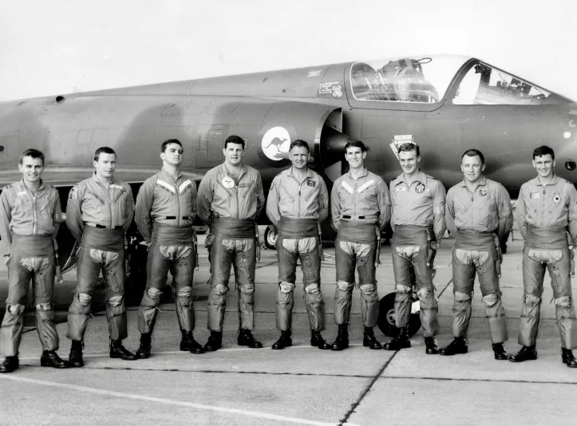
Stew (centre) No 10 Mirage air defence course (26 October 1967). (Note Aviation Club Treasurer, Mac Cottrell – far right.)

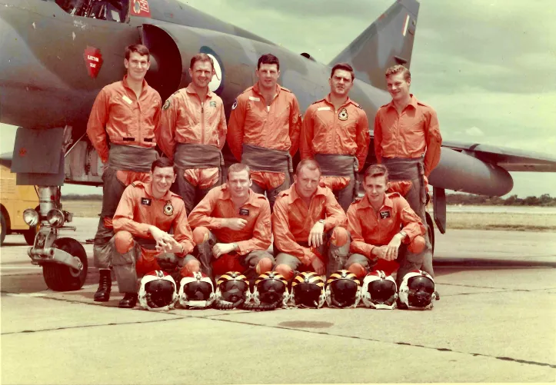
Stew (standing, second from left) No 10 Mirage air defence course, 26 October 1967. (Mac Cottrell kneeling, first from left) (Many thanks to Mac for these photos.)

