Amazing WW2 Aircraft Facts

These are very moving statistics.

On average 6600 American service men died per MONTH, during WW2 (about 220 a day).

People who were not around during WW2 have no understanding of the magnitude.

This gives some insight.

276,000 aircraft manufactured in the US .
43,000 planes lost overseas, including 23,000 in combat.
14,000 lost in the continental U.S.

The staggering cost of aircraft in 1945 dollars. (A 1945 dollar is worth $13.16 today. That P-38 would now cost $1,278,454.52)

B-17 $204,370 P-40 $44,892.
B-24 $215,516 P-47 $85,578.
B-25 $142,194 P-51 $51,572.
B-26 $192,426 C-47 $88,574.
B-29 $605,360 PT-17 $15,052.
P-38 $97,147 AT-6 $22,952.

From Germany's invasion of Poland 1 September 1939 until Japan 's surrender on 2 September 1945 = 2,433 days. America lost an average of 170 planes a day; (a higher rate if you consider that the US entered WWII on 7 December 1941).

A B-17 carried 2,500 gallons of high octane fuel and carried a crew of 10 airmen.

9.7 billion gallons of gasoline consumed.
108 million hours flown.

460 thousand million rounds of aircraft ammo fired overseas.
7.9 million bombs dropped overseas.
2.3 million combat flights.
299,230 aircraft used.
808,471 aircraft engines used.
799,972 propellers.

WWII’s MOST-PRODUCED COMBAT AIRCRAFT

Russian Ilyushin IL-2 Sturmovik 36,183
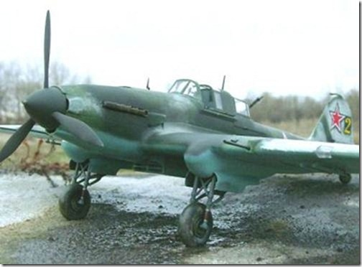

Yakolev Yak-1,-3,-7, -9 31,000
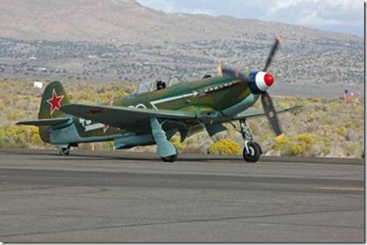

Messerschmitt Bf-109 30,480
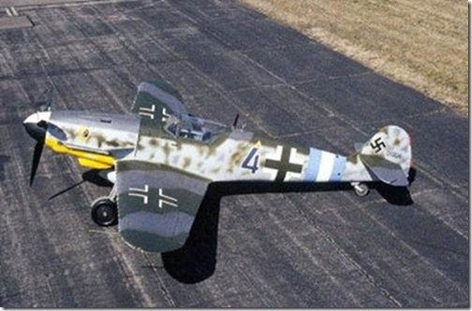

Focke-Wulf Fw-190 29,001
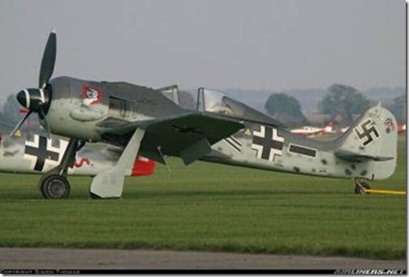

Supermarine Spitfire 20,351
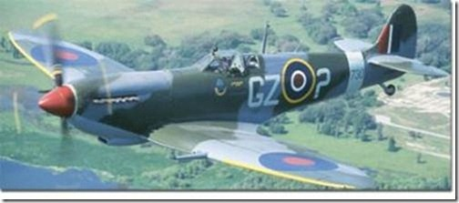

Convair B-24/PB4Y Liberator/Privateer 18,482
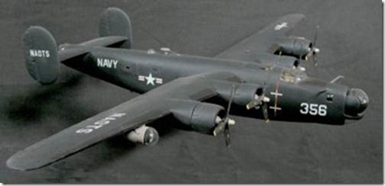

Republic P-47 Thunderbolt 15,686
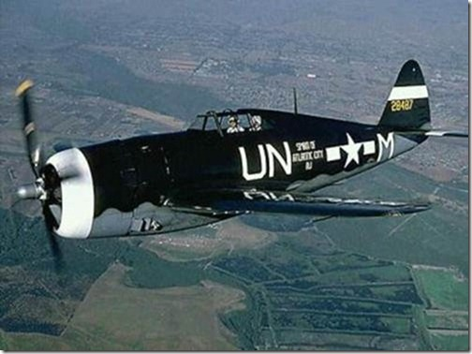

North American P-51 Mustang 15,875
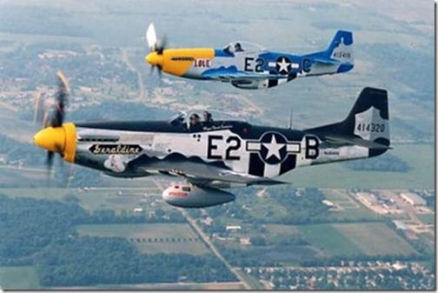

Junkers Ju-88 15,000
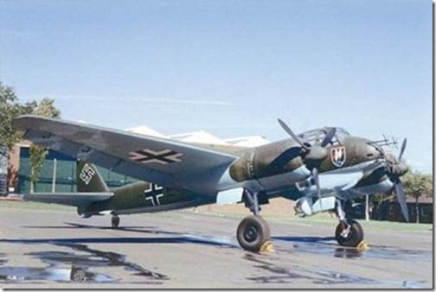

Hawker Hurricane 14,533
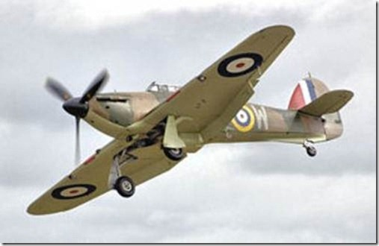

Curtiss P-40 Warhawk 13,738
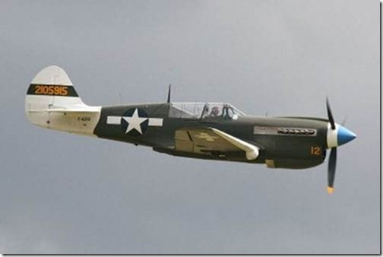

Boeing B-17 Flying Fortress 12,731
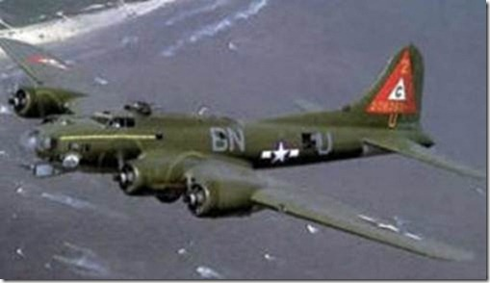

Vought F4U Corsair 12,571
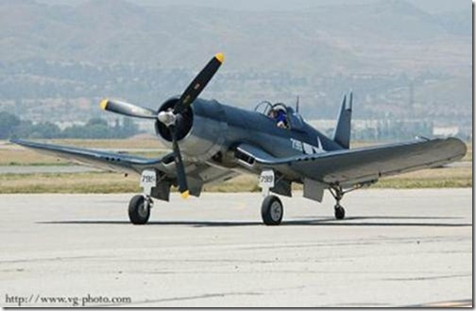

Grumman F6F Hellcat 12,275
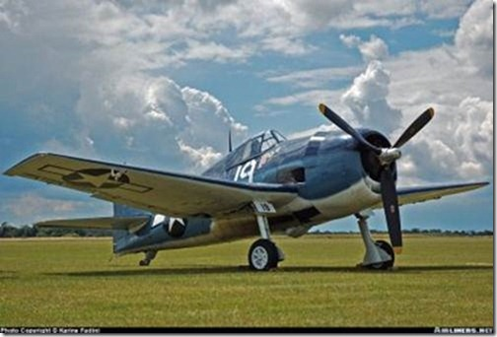

Petlyakov Pe-2 11,400
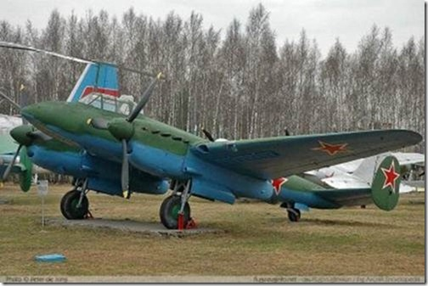

Lockheed P-38 Lightning 10,037
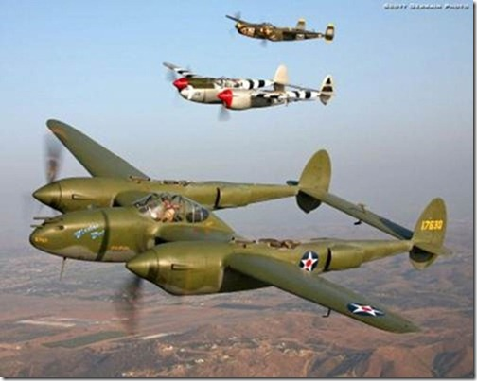

Mitsubishi A6M Zero 10,449
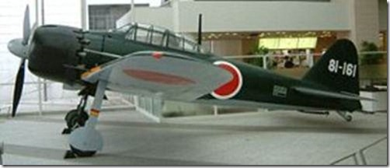

North American B-25 Mitchell 9,984
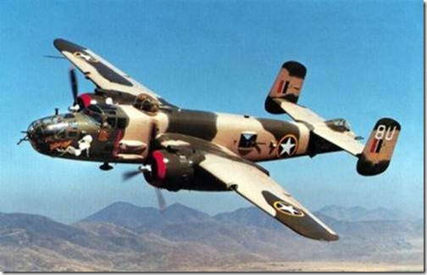

Lavochkin LaGG-5 9,920

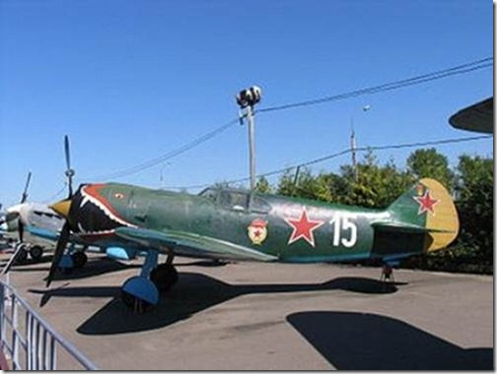

Grumman TBM Avenger 9,837
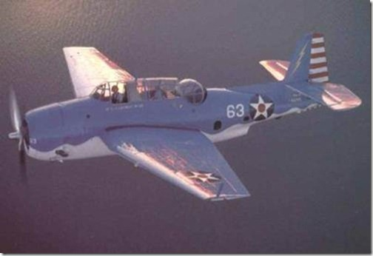

Bell P-39 Airacobra 9,584
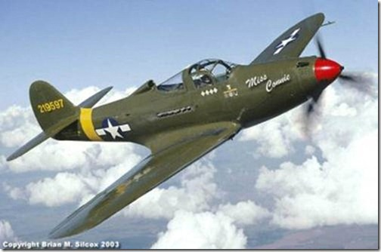

Nakajima Ki-43 Oscar 5,919
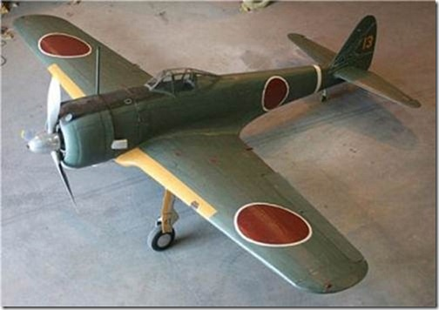

DeHavilland Mosquito 7,780
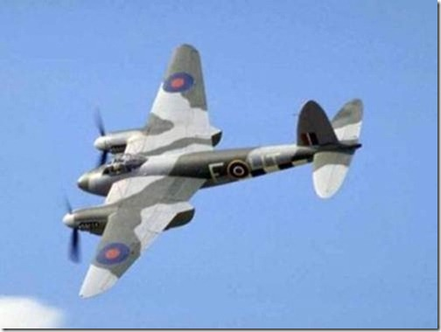

Avro Lancaster 7,377
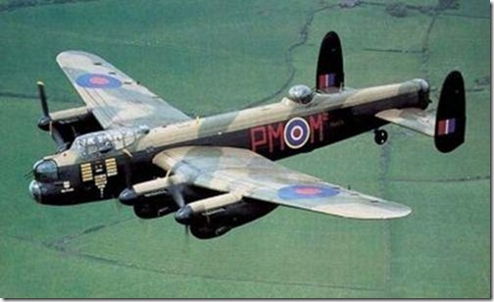

Heinkel He-111 6,508
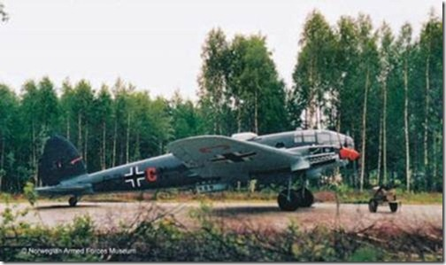

Handley-Page Halifax 6,176
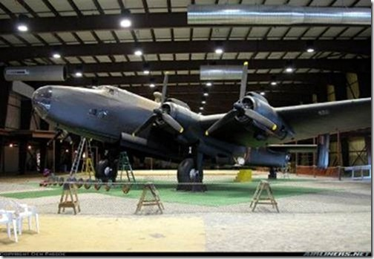

Messerschmitt Bf-110 6,150
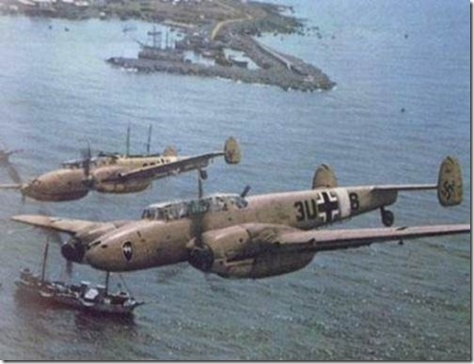

Lavochkin LaGG-7 5,753
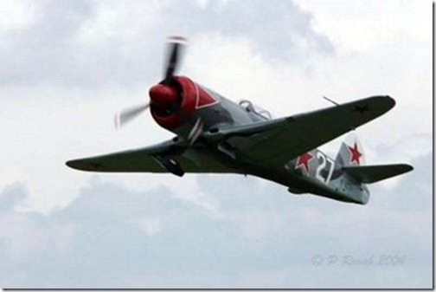

Boeing B-29 Superfortress 3,970
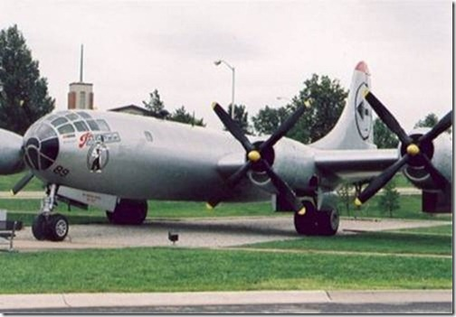

Short Stirling 2,383
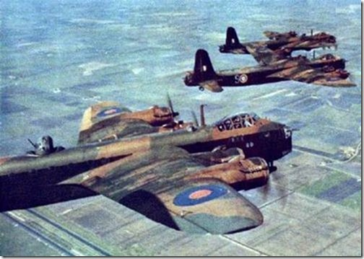
The US lost 14,903 pilots, aircrew and support personnel plus 13,873 airplanes --- inside the continental United States. There were 52,651 aircraft accidents (6,039 involving fatalities) in 45 months. Average 1,170 aircraft accidents per month---- nearly 40 a day.

It gets worse.....
Almost 1,000 planes disappeared en route from the US to foreign climes. But 43,581 aircraft were lost overseas including 22,948 on combat missions (18,418 in Europe ) and 20,633 due to non-combat causes overseas.

In a single 376 plane raid in August 1943, 60 B-17s were shot down. That was a 16 percent loss rate and meant 600 empty bunks in England. In 1942-43, it was statistically impossible for bomber crews to complete the intended 25-mission tour in Europe .

Pacific theatre losses were far less (4,530 in combat) owing to smaller forces committed. The B-29 mission against Tokyo on May 25, 1945, cost 26 Superfortresses, 5.6 percent of the 464 dispatched from the Marianas .

On average, 6,600 American servicemen died per month during WWII, about 220 a day. Over 40,000 airmen were killed in combat and another 18,000 wounded. Some 12,000 missing men were declared dead, including those "liberated" by the Soviets but never returned. More than 41,000 were captured. Half of the 5,400 held by the Japanese died in captivity, compared with one-tenth in German hands. Total combat casualties were 121,867.

The US forces peak strength was in 1944 with 2,372,000 personnel, nearly twice the previous year's figure.

Losses were huge---but so were production totals. From 1941 through 1945, American industry delivered more than 276,000 military aircraft. That was not only for US Army, Navy and Marine Corps, but also for allies as diverse as Britain, Australia, China and Russia.

Our enemies took massive losses. Through much of 1944, the Luftwaffe sustained hemorrhaging of 25% of aircrews and 40 planes a month.

Experience Level:
Uncle Sam sent many men to war with minimum training. Some fighter pilots entered combat in 1942 with less than 1 hour in their assigned aircraft. The 357th Fighter Group (The Yoxford Boys) went to England in late 1943 having trained on P-39s, then flew Mustangs. They never saw a Mustang until the first combat mission.

With the arrival of new aircraft, many units transitioned in combat. The attitude was, "They all have a stick and a throttle. Go fly `em." When the famed 4th Fighter Group converted from P-47s to P-51s in Feb 44, there was no time to stand down for an orderly transition. The Group commander, Col. Donald Blakeslee, said, "You can learn to fly 51s on the way to the target".

A future P-47 ace said, "I was sent to England to die." Many bomber crews were still learning their trade. Of Jimmy Doolittle's 15 pilots on the April 1942 Tokyo raid, only five had won their wings before 1941. All but one of the 16 co-pilots were less than a year out of flight school.

In WW2, safety took a back seat to combat. The AAF's worst accident rate was recorded by the A-36 Invader version of the P-51: a staggering 274 accidents per 100,000 flying hours. Next worst were the P-39 at 245, the P-40 at 188, and the P-38 at 139. All were Allison powered.

Bomber wrecks were fewer but more expensive. The B-17 and B-24 averaged 30 and 35 accidents per 100,000 flight hours respectively-- a horrific figure considering that from 1980 to 2000 the Air Force's major mishap rate was less than 2.

The B-29 was even worse at 40 per 100,000 hours; the world's most sophisticated, most capable and most expensive bomber was too urgently needed to be able to stand down for mere safety reasons.

(Compare: when a $2.1 billion B-2 crashed in 2008, the Air Force declared a two-month "safety pause").

The B-29 was no better for maintenance. Although the R3350 was known as a complicated, troublesome power-plant, only half the mechanics had previous experience with it.

Navigators:
Perhaps the greatest success story concerned Navigators. The Army graduated some 50,000 during WW2.

Many had never flown out of sight of land before leaving "Uncle Sugar" for a war zone. Yet they found their way across oceans and continents without getting lost or running out of fuel - a tribute to the AAF's training.

At its height in mid-1944, the USAAF had 2.6 million people and nearly 80,000 aircraft of all types.

Today the US Air Force employs 327,000 active personnel (plus 170,000 civilians) with 5,500+ manned and perhaps 200 unmanned aircraft. That's about 12% of the manpower and 7% of the airplanes of the WW2 peak.

SUMMATION:
Another war like that of 1939-45 is doubtful, as fighters and bombers have given way to helicopters and remotely-controlled drones, eg. over Afghanistan and Iraq. But within our living memory, men left the earth in 1,000-plane formations and fought major battles five miles high, leaving a legacy that remains timeless.

